**Restaurant Info**

Punjab Food Corner

Logo :



Side image :

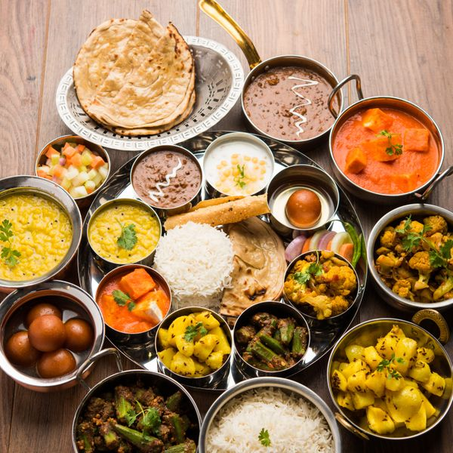

Delivery time : 28 - 38 minutes

Food items :

*Snacks*

**Samosa**

Crispy turnovers filled with spiced potatoes and peas. Price : $1.25

**Golgappa (7 pcs)**

Round hollow puri fried and filled with a mixture of flavoured water, tamarind chutney, chilly, chat masala, potatoes, and onions. Price : $6.99

**Tikki Chaat**

Two potato patties smothered with chickpeas curry garnished with diced onions, and sliced carrots drizzled with tamarind sauce and mint chutney. Price : $6.99

**Fried Rice**

Basmati rice cooked with mixed vegetables. Price : $8.99

*Burgers*

**Vegetable Burger**

Fried potato patty in a bun with lettuce, onion, tomato, and housemade sauces. Price : $6.99

**Noodle Burger**

Indian style fried potato patty in a bun with noodles, lettuce, onion, tomato, and housemade sauces. Price : $6.99

**Chicken Burger**

Fried chicken patty in a bun with lettuce, onion, and house made sauces. Price : $6.99

**Butter Chicken Burger** Price :$7.99

**Vegetable Burger with Fries and Drink** Price **:** $8.99

*Breads*

**Tawa Roti** Price : $0.90

**Tandoori Roti** Price : $1.99

**Coriander Naan** Price : $2.99

**Butter Naan** Price : $2.99

**Garlic Naan** Leavened flour flatbread with a hint of garlic to accentuate the taste of any dish. Price : $2.99

*Sweets*

**Gulaab Jamun** (2 pcs) (Per Piece)

Soft, spongy, and melt in your mouth milk balls drenched in syrup. One order comes with two pieces. Price : $2.99

**Gulaab Jamun with Layered Coconut** (Per Piece)

Soft, spongy, and melt in your mouth milk balls drenched in syrup. Price : $1.99

**Gulaab Jamun** (1 lb)

Soft, spongy, and melt in your mouth milk balls drenched in syrup. One order comes with one pound. Price : $10.99

**Gulaab Jamun with Layered Coconut** (1 lb)

Soft, spongy, and melt in your mouth milk balls drenched in syrup. One order comes with one pound. Price : $12.99

**Milk Cake** (Per Piece) Price : $2.49

**Milk Cake** (1 lb)

One order comes with one pound. Price : $14.99

**Rasmalai** (3 pcs)

Made with spongy cottage cheese balls dunked into an aromatic milk syrup. One order comes with three pieces. Price : $5.99

McDonald’s

Logo :

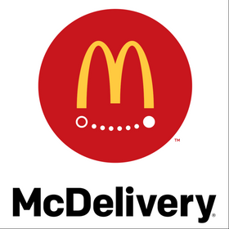

Side image :

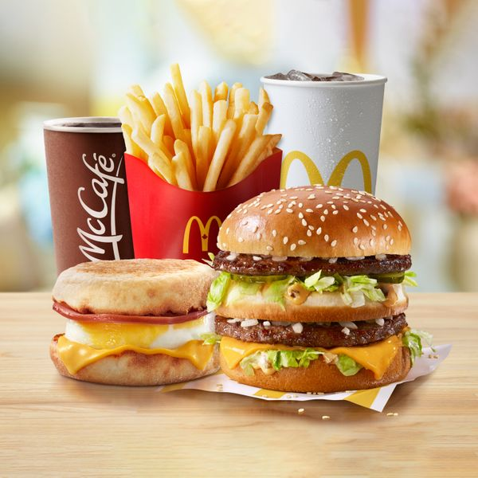

Delivery Time - 21 - 31 minutes

*Breakfast Sandwiches meals*

**Sausage 'N Egg McMuffin Extra Value Meal** [590.0 Cals]

$6.59

**Sausage McMuffin Extra Value Meal** [530.0 Cals]

$5.49

**Sausage McGriddle Extra Value Meal** [560.0 Cals]

$6.49

**Bacon, Egg & Cheese McGriddles Extra Value Meal** [560.0 Cals]

$6.99

*Hot Drinks*

**Premium Roast Brewed Coffee** [3.0 Cals]

$1.49

**Premium Roast Decaf Coffee** [0.0 Cals]

$1.49

**Peppermint Tea** [0.0 Cals]

$1.49

**Green Tea** [0.0 Cals]

$1.49

**Latte (2% Milk)** [130.0 Cals] Price : $2.69

**French Vanilla Latte** (2% Milk) [180.0 Cals]

$3.19

*Snacks and sides*

**Hash Brown** [160.0 Cals]

$1.99

**Blueberry Muffin** [430.0 Cals]

$1.69

**Banana Chocolate Chunk Muffin** [430.0 Cals]

$1.69

**Fruit & Fibre Muffin** [380.0 Cals]

$1.69

**Cranberry Orange Muffin** [360.0 Cals]

$1.69

A&W

Logo :



Side Image :

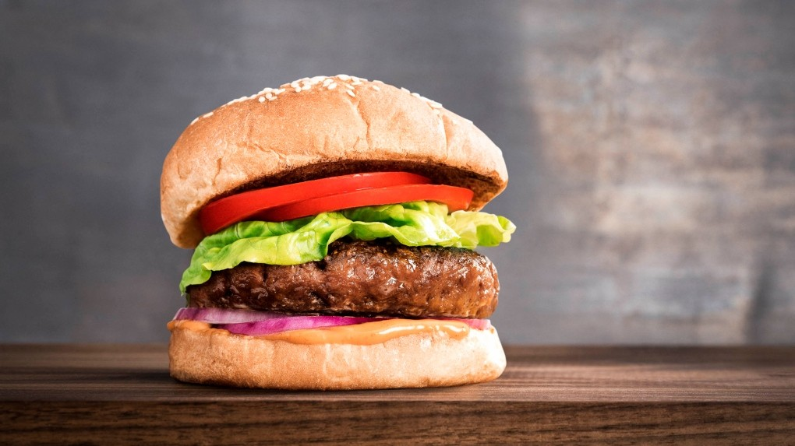

Delivery Times : 36 - 46 minutes

*Burgers*

**Teen Burger**

A 100% pure beef patty topped with cheddar cheese, bacon, lettuce, onion, tomato, pickles, and Teen® sauce, served on a freshly toasted sesame seed...

$6.59

**Double Teen Burger**

Two 100% pure beef patties topped with cheddar cheese, bacon, lettuce, tomato, pickles, and Teen® sauce, served on a freshly toasted bun.

$8.09

**Mozza Burger**

A perfectly seasoned 100% pure beef patty – raised without the use of hormones or steroids – topped with real mozzarella cheese, mouth-watering bacon...

$6.49

**Cheddar Bacon Uncle Burger**

A 5 oz 100% pure beef patty topped with cheddar cheese, bacon, red onion, lettuce, pickles and two slices of tomato, served on a freshly toasted...

$8.49

**Mama Burger**

A perfectly seasoned 100% pure beef patty – raised without the use of hormones or steroids – topped with pickles, a slice of onion, ketchup, mustard,

$4.99

**Beyond Meat Burger**

A 3oz 100% plant-based protein patty - topped with tomato, lettuce, red onion, pickles, mayo, ketchup, and mustard, served on a freshly toasted...

$7.19

*Sides*

**Russet Thick-Cut Fries**

A&W's fries are thick-cut and served with the skin on, so you’re always reminded that they’re made from 100% Canadian-grown Russet potatoes.

$2.89

**Onion Rings**

A&W's classic onion rings are handcrafted in-store, made from fresh onions.

$4.39

**Poutine**

Russet thick-cut fries served with cheese and gravy.

$4.94

**Hash Brown**

A&W's golden-brown hash browns are made from the finest potatoes and cooked just the way you like them – fluffy on the inside and crispy on the...

$1.89

**Hot Apple Turnover**

Hot apple turnover dusted with cinnamon sugar.

$1.29

*Beverages*

**Coffee**

Please specify milk, cream, and sugar in special instructions.

$1.60

**Soft Drink**

Fountain soft drinks in your choice of size.

$1.89

**Dasani Bottled Water** (591 ml)

Refreshing Dasani water.

$2.39

**Juice** Your choice of apple or orange juice. Price : $2.29

Koya Japan

Logo :

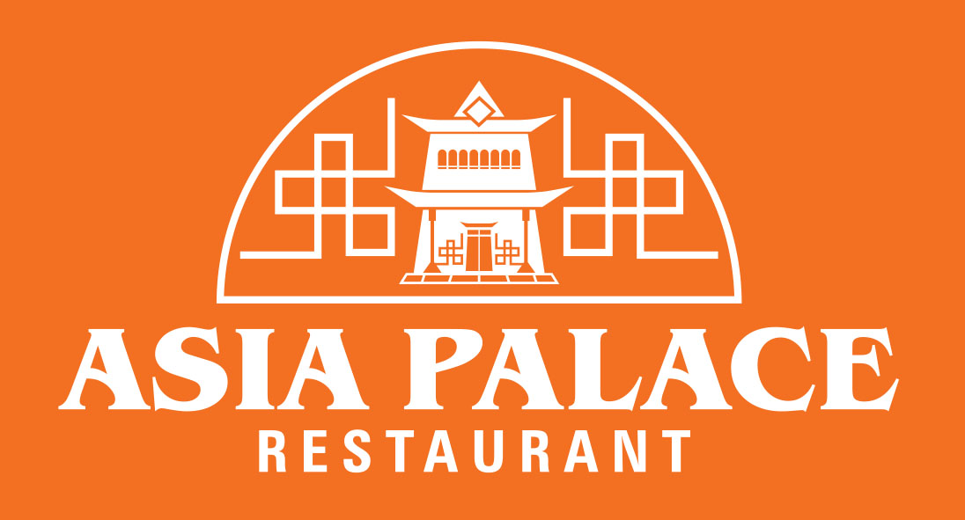

Side image :

Delivery time : 36 - 47 minutes

*Appetizers*

**Crab Rangoon** (5 pcs)

Five deep-fried dumplings filled with cream cheese and crab meat.

$6.95

**Shrimp Salad Rolls** (2 pcs)

Fresh vegetables, rice noodles, steamed shrimp, and herbs wrapped in rice paper.

$4.95

**Shrimp and Pork Salad Rolls** (2 pcs)

Fresh vegetables, rice noodles, steamed shrimp, pork, and herbs wrapped in rice paper.

$5.95

**BBQ Pork Meat Ball Salad Rolls** (2 pcs)

Fresh vegetables, rice noodles, barbeque pork meatballs, and herbs wrapped in rice paper.

$4.9

**Veggie Spring Rolls** (5 pcs)

Minced veggies rolled in a spring roll wrapper and deep-fried.

$4.25

*Congee Dishes ( A breakfast of filling rice porridge )*

**Chicken Congee**

A savoury rice pudding topped with seasoned chicken and green onions.

$6.95

**Sliced Fish Congee**

Savoury rice pudding topped with seasoned white fish and green onions.

$6.95

**Beef Congee**

A savoury rice pudding topped with seasoned beef and green onions.

$6.95

**Seafood and Pork Congee**

A savoury rice pudding topped with seasoned pork, assorted seafood, and green onions.

$7.95

**Preserved Egg and Pork Congee**

A savoury rice pudding topped with seasoned pork, minced preserved edd, and green onions.

$6.95

*Casserole (Hot Pot) Dishes*

**Braised Beef Brisket**

Braised beef brisket cooked in a flavourful sauce.

$14.95

**Chicken with Chestnut**

Tender pieces of chicken cooked with roasted chestnuts in a soy-based sauce.

$13.95

**Salted Fish, Chicken, and Eggplant**

$13.95

**Deluxe Hot Pot, Mixed Veggies, Fried Tofu, Shrimp, Scallop, Squid, BBQ Pork, Chicken**

Mixed vegetables, fried tofu, shrimp, scallops, squid, barbeque pork, and tender chicken all together in a flavourful sauce.

$14.95

**Curry Beef Brisket**

Beef brisket in a flavourful curry sauce.

$14.95

*Extras*

**Rice**

$1.00

**Small Plain Fried Rice**

$3.50

**Fried Egg**

$1.50